Please follow below steps to install and setup the DFN release note plugin for Bamboo.

**Assumptions.**

* *Release_Note_Template.docx* is available in each code base home directory.
* Only projects having pom.xml can be used to generate release notes with current plugin version.

**Steps to follow.**

1. 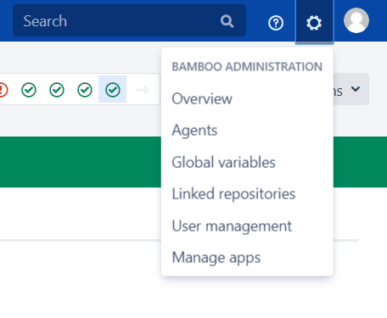In order to install the plugin, first go to manage apps window.
2. Click Upload App link  
     
   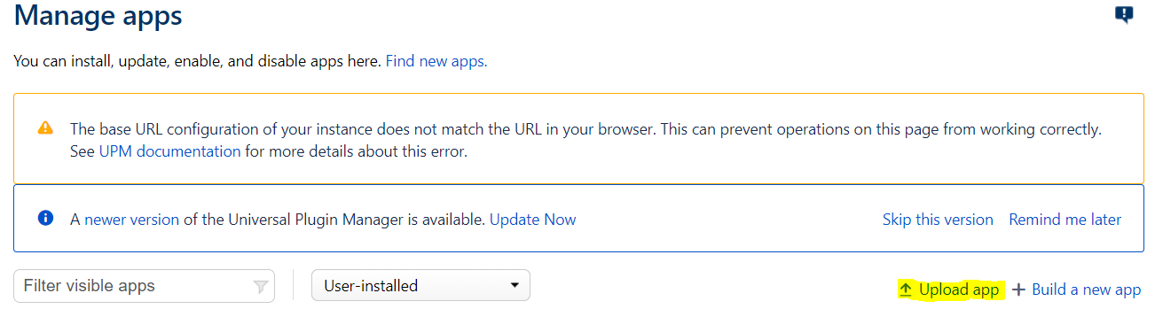
3. In popup window, please select provided DirectFN release note plugin *jar* or *obr* file.  
     
   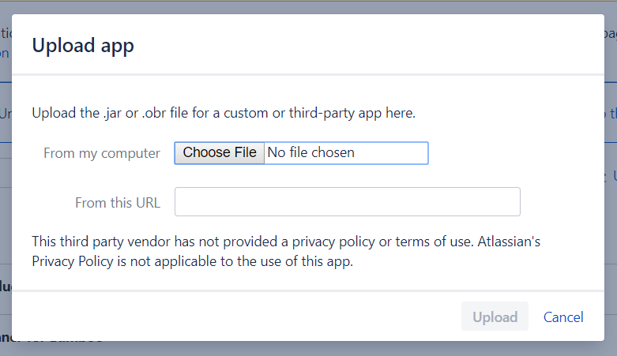
4. Once it is done, click upload.

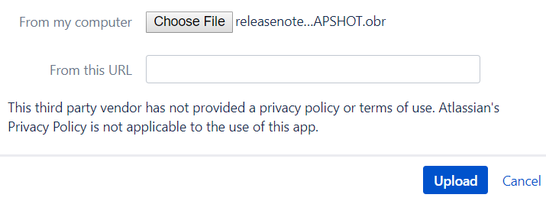

1. Wait till it is installed.  
     
   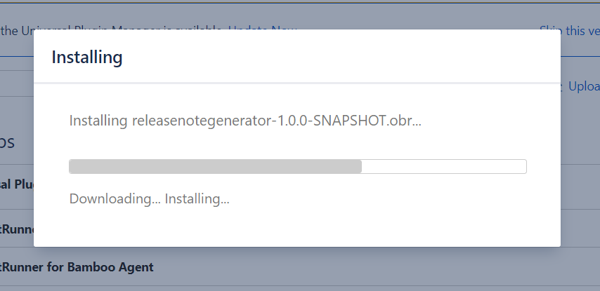
2. If everything went well up to now, you can see this message.  
     
   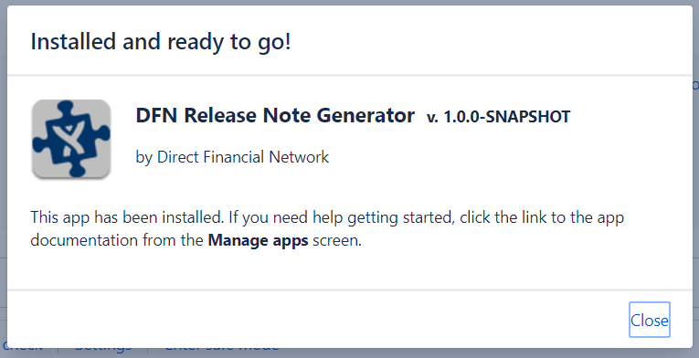
3. Select a particular plan and go to its configure plan window. Please select *variables* tab.  
   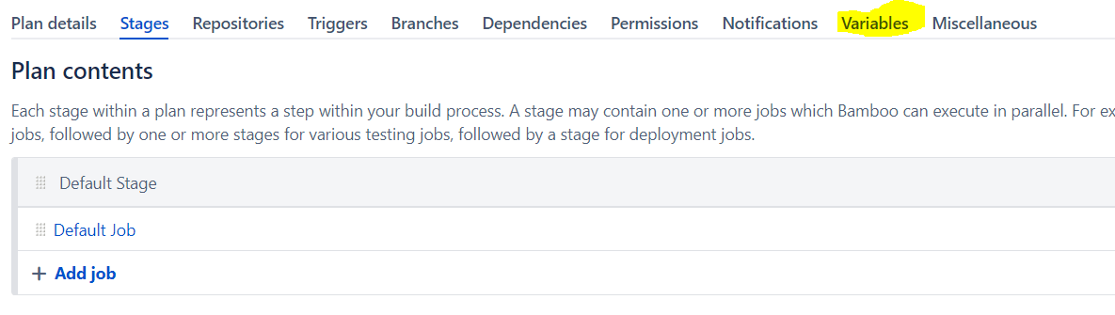
4. Add “*oldCommitIdForReleaseNote*” variable with no value in it. This will be used later to run customized plans If needed when generating specific release note with selected old commit.   
   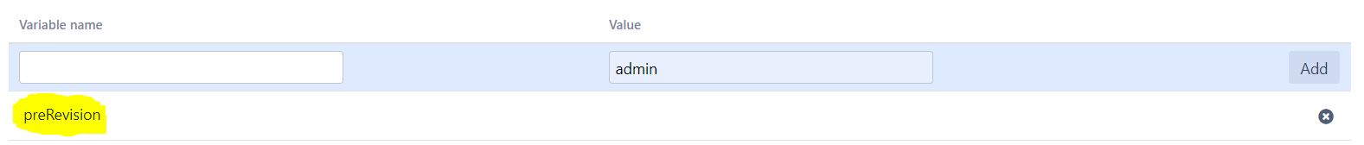
5. Now go to *stages* tab and select the job that you need to add the release note generator task.  
   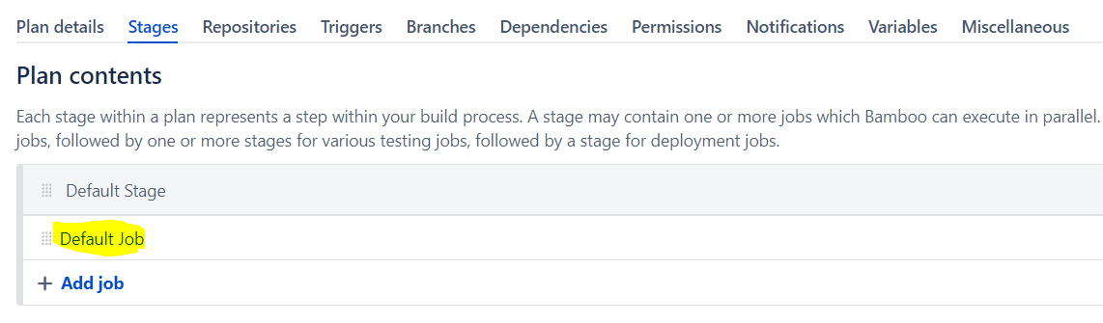
6. Please click add task button to add the release note task

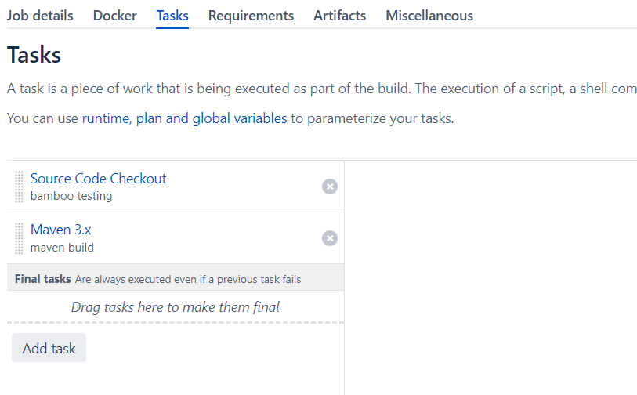

1. Search for release note task.  
   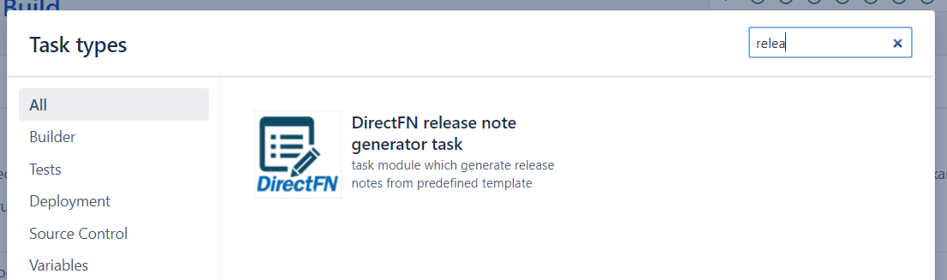
2. After adding it. you can see the configuration window as follows   
   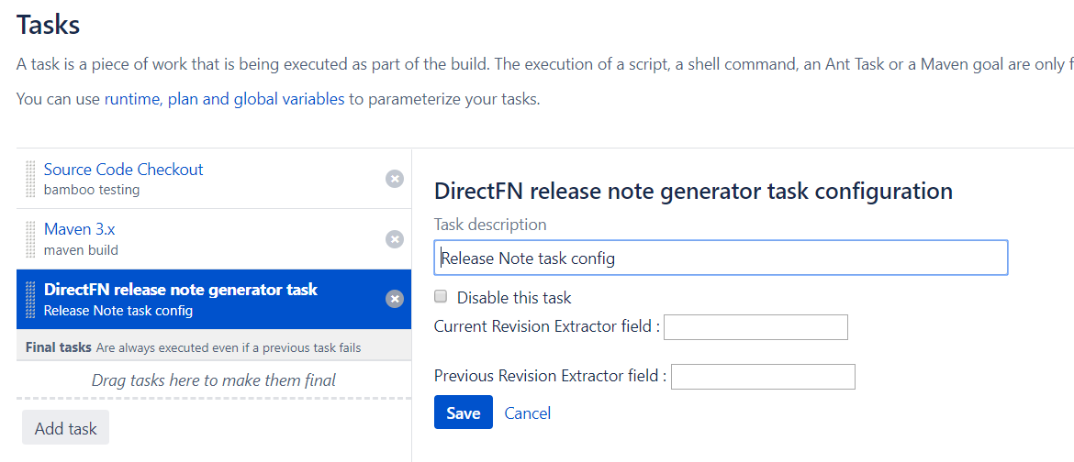
3. Give own task description and Add “${bamboo.planRepository.revision}” value to first input text box and “${bamboo.planRepository.previousRevision}” value to second input box and click save. If every steps are done correctly, you can see this message.

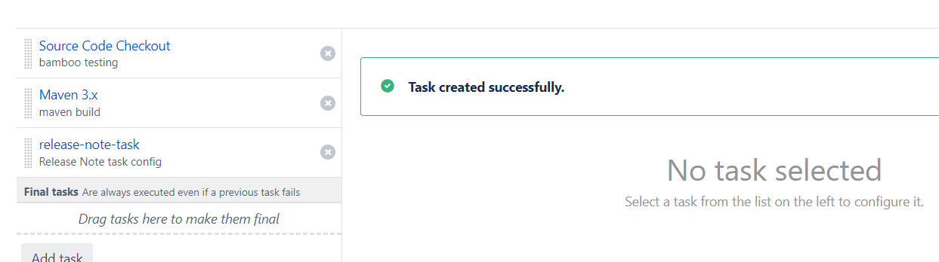

1. Now everything is setup and please run the plan in order to generate the release note.  
   Note: release note is generated between last build ran Revision to current committed Revision only. If you need to generate the release note from specific release to current release, please run customized   
   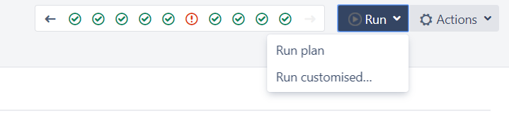

And add specific release value for the variable “preRevision”

